Local Bridge

🌐 What is a Local Bridge?
# Source: Chatgpt (GPT‑5 Mini) at [12/18/2025]
A Local Bridge is a type of network bridge that connects two or more network segments (LANs) within the same physical location — such as the same building or campus. It works at Layer 2 of the OSI model and uses MAC addresses to forward data between the connected segments.
✅ A Local Bridge helps devices on separate LANs communicate as if they were on the same network, without needing routing.

🔄 What It Does
# Source: Chatgpt (GPT‑5 Mini) at [12/18/2025]
- Connects separate LAN segments locally
- Filters traffic using MAC address tables
- Forwards frames only when the destination is on a different segment
- Reduces collisions and improves performance over traditional hubs

🧱 Example Network
# Source: Chatgpt (GPT‑5 Mini) at [12/18/2025]
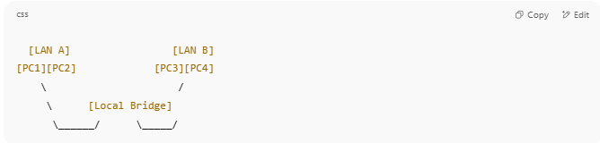

[LAN A] [LAN B]
[PC1][PC2] [PC3][PC4]
\ /
\ [Local Bridge]
\______/ \_____/

- LAN A and LAN B are now part of the same broadcast domain
- Devices can talk to each other directly

🆚 Local Bridge vs Remote Bridge
# Source: Chatgpt (GPT‑5 Mini) at [12/18/2025]
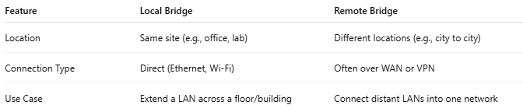

Feature | Local Bridge | Remote Bridge
Location | Same site (e.g., office, lab) | Different locations (e.g., city to city)
Connection Type | Direct (Ethernet, Wi-Fi) | Often over WAN or VPN
Use Case | Extend a LAN across a floor/building | Connect distant LANs into one network

✅ Use Cases
# Source: Chatgpt (GPT‑5 Mini) at [12/18/2025]
- Connecting two Ethernet switches in the same building
- Bridging wired and wireless networks
- Creating larger local LANs for labs, classrooms, or offices

❌ Limitations
# Source: Chatgpt (GPT‑5 Mini) at [12/18/2025]
- ❌ Cannot route traffic between different subnets (no Layer 3 logic)
- ❌ Still part of the same broadcast domain — can lead to traffic congestion
- ❌ Not used in large modern networks (replaced by managed switches/VLANs)

📌 Summary
# Source: Chatgpt (GPT‑5 Mini) at [12/18/2025]
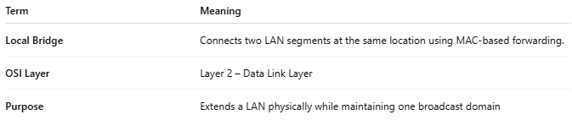
Term | Meaning
Local Bridge | Connects two LAN segments at the same location using MAC-based forwarding.
OSI Layer | Layer 2 – Data Link Layer
Purpose | Extends a LAN physically while maintaining one broadcast domain

